West Area Planning Committee | 15 February 2012

Application Number: | 12/00046/FUL
Decision Due by: | 2 March 2012
Proposal: | Retention of use as student accommodation.
Site Address: | 229 Cowley Road (Appendix 1)
Ward: | St Clement's Ward

Agent: | Kemp And Kemp | Applicant: | Mandeep Kandola

Call in – The application was called in by Councillors Young, Benjamin, Altaf-Khan and Fooks on the grounds that the house is too large for a family house and well adapted already for student accommodation. New housing strategy is for preference to be given for student housing to be located on main roads. Such accommodation is safer for students and avoids the out of hours nuisance caused to residents in side roads.

Recommendation: To refuse planning permission for the following reason:

- The proposed development would result in the net loss of a self contained residential dwelling. The application is therefore contrary to policy HS10 of the Oxford Local Plan 2001 - 2016.

Planning Obligations:
Notwithstanding the recommendation above, in the event that committee is minded to support the planning application, then, in accordance with the Planning Obligations SPD and the Sites and Housing Development Plan Document (Proposed Submission) the following contributions would be required to mitigate the impact of the proposals on City and County Services and affordable housing delivery. The contributions set out below are indexed linked to values at 2006 levels and should be increased accordingly to the real value at the time of payment. The applicant has indicated in relation to the first item that he is unable to make the contributions in full for viability reasons. A letter of explanation is attached as Appendix 2.

- £38,427.20 towards affordable housing
- £780 towards indoor sports facilities
- £819 towards library infrastructure
- £1794 towards cycle safety measures

Principal Planning Policies:

Oxford Local Plan 2001-2016 (OLP)

CP1 - Development Proposals
CP6 - Efficient Use of Land & Density
CP10 - Siting Development to Meet Functional Needs
TR3 - Car Parking Standards
TR4 - Pedestrian & Cycle Facilities
HS10 - Loss of Dwellings
HS19 - Privacy & Amenity

Oxford Core Strategy 2026

CS17_ - Infrastructure and developer contributions
CS25_ - Student accommodation

Sites and Housing DPD – Proposed Submission

HP5_ - Location of Student Accommodation
HP6_ - Affordable Housing from Student Accommodation

Other Material Considerations:
- PPS 1 - Delivering Sustainable Development
- PPS 3 - Housing
- PPG 13 - Transport
- Regional Spatial Strategy for the South East
- Planning Obligations SPD
- Parking Standards, Transport Assessments and Travel Plans SPD

Relevant Site History:
11/02068/FUL - Change of use of dwelling house to house in multiple occupation (HMO) – Withdrawn

10/00562/FUL - Three storey rear extension (retrospective) - Approved

APP/G3110/A/C/10/2123487 - Appeal by Ms B Kaur against the enforcement notice issued by Oxford City Council for the unauthorised change of use of 229 Cowley Road from a dwelling house to student accommodation - Dismissed

09/02099/FUL - Retention of rear extension to 229 Cowley Road. Change of use from residential dwelling to student accommodation. Provision of cycle parking and bin storage – Refused

09/00087/FUL - Erection of 2/3 storey building fronting Bartlemas Road to provide 9 study bedrooms at rear of 229/231/233 Cowley Road – Refused

09/00032/FUL - Retention of extension to 229/ 231/ Cowley Road and use of 229, 231 and 233 Cowley Road as student accommodation (39 bedrooms) including change of use from dwelling (229) and guest house (231, 233) – Withdrawn

08/00754/FUL - Retention of extension to 229 and 231 Cowley Road. Retention of use of 229, 231 and 233 Cowley Road as student accommodation (39 bedrooms) including change of use from dwelling (229) and guest house (231/233) – Withdrawn

05/02433/FUL - Single and three storey rear extensions to 229 and 231 Cowley Road. Raise roof, two dormers in front elevations and single dormer to rear of 231 Cowley Road – Approved in Part

05/01016/FUL - Single, two and third storey rear extension - Approved

Public Comments:

Statutory and Internal Consultees:
Highways And Traffic – No objection subject to condition to prevent students bringing cars in to Oxford and cycle parking and contribution towards cycle safety measures
Thames Water Utilities Limited – No objection

Officers Assessment:

Site Description and Proposal

The application site comprises No 229 Cowley Road, a three storey end of terrace property. The authorised use is as a dwelling house. However the property has been operating as student accommodation for a number of years without the benefit of planning permission. The adjoining properties at Nos 231 and 233 (also in the ownership of the applicant) are in use as student accommodation having gained planning permission in 2009.

2. The application seeks permission to retain the property in use a student accommodation.

3. Officers consider the determining issue in this case to be the loss of the dwelling house.

Planning History

- There is a lengthy planning history on this site (set out above). For ease officers set out below the key points:

  - Planning permission granted for single and three storey rear extension in 2006, increasing the number of bedrooms from 4 to 6;

  - Three storey extension approved in 2006 built 1.9m longer than approved, omitting the single storey element entirely. Further investigation determined that the property was now in use as student accommodation;

  - Following several aborted application submission an application was refused in 2009 for the retention of the extension and use of the property as student accommodation;

  - Following the refusal in 2009 the Planning Department issued an Enforcement Notice requiring the use to cease and the extensions to be regularised. An application to retain the extension as built was approved in April 2010, however the Enforcement Notice was Appealed by the applicant;

  - A Planning Inspector dismissed the appeal in June 2010 on the grounds that the change of use to student accommodation, albeit retrospective, would result in the loss of a dwelling house contrary to policy HS10 of the Local Plan. The appeal decision is attached as Appendix 3.

- In considering the appeal the Inspector raised no other concerns, e.g. residential amenity and car parking, and accepted that the location was otherwise suitable for student accommodation. Officers will therefore focus their assessment on the matters of contention.

Loss of Dwelling

- Local Plan policy HS10 states that planning permission will not be granted for development which results in the net loss of self-contained residential accommodation. The loss of the dwelling house would therefore be contrary to policy HS10. In addition to this, the Planning Inspector considered this issue in the context of a number of material considerations (see Appeal Decision) and concluded that none of the other matters outweighed the conflict with the adopted local plan policy.

- Since the appeal decision in July 2010 there has been no shift in the policy context so far as Local Plan policy HS10 is concerned and as such officers can find no planning reason to take a different view to the Planning Inspector.

Affordable Housing

- Policy HP6 of the Site and Housing Development Plan Document (Proposed Submission) states that ‘Planning Permission will only be granted for new student accommodation that includes 8 or more bedrooms if a financial contribution is secured towards delivering affordable housing elsewhere in Oxford.’ The application proposes 13 student study bedrooms and therefore triggers the requirement for affordable housing delivery (this figure is set out above). The Committee should be mindful that whilst the document is not adopted it is a material planning consideration and does carry some weight in determining the planning application. The applicants have submitted a letter explaining why they are not able to pay the full contribution and have offered £10,000 towards off-site affordable housing and the other infrastructure contributions.

- In the event that the Committee supports the application officers would draw its attention to the new requirements of policy HP6 and recommend that in resolving to grant planning permission authority be delegated to officers to issue the planning permission on completion of a legal agreement and appropriate contribution towards affordable housing.

Parking

- The application does not include any off street car parking. However if Committee are minded to support the proposal officers can confirm that it is reasonable to impose a condition in accordance with Core Strategy policy CS25 to prevent students resident at the property from bringing cars into Oxford. The Highway Authority agrees with this approach. A condition is also recommended to ensure that cycle parking is provided.

Conclusion: There has been no change in circumstances since the enforcement appeal was dismissed. The proposal would still be contrary to Local Plan policy HS10 and as such officers would recommend that planning permission be refused. Should the Committee resolve to support the application officers would recommend the imposition of the conditions set out in the report and that authority be delegated to officers to issue the planning permission on completion of a legal agreement to secure appropriate contributions to off – site affordable housing.

Human Rights Act 1998

Officers have considered the implications of the Human Rights Act 1998 in reaching a recommendation to refuse this application. They consider that the interference with the human rights of the applicant under Article 8/Article 1 of Protocol 1 is justifiable and proportionate for the protection of the rights and freedom of others or the control of his/her property in this way is in accordance with the general interest.

Section 17 of the Crime and Disorder Act 1998

Officers have considered, with due regard, the likely effect of the proposal on the need to reduce crime and disorder as part of the determination of this application, in accordance with section 17 of the Crime and Disorder Act 1998. In reaching a recommendation to refuse planning permission, officers consider that the proposal will not undermine crime prevention or the promotion of community safety.

Background Papers: 12/00046/FUL
Contact Officer: Steven Roberts
Extension: 2221
Date: 31 January 2012
Appendix 1 – 229 Cowley Road

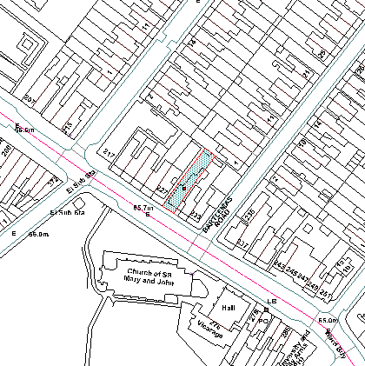

Appendix 2 – Letter from applicant regarding contributions

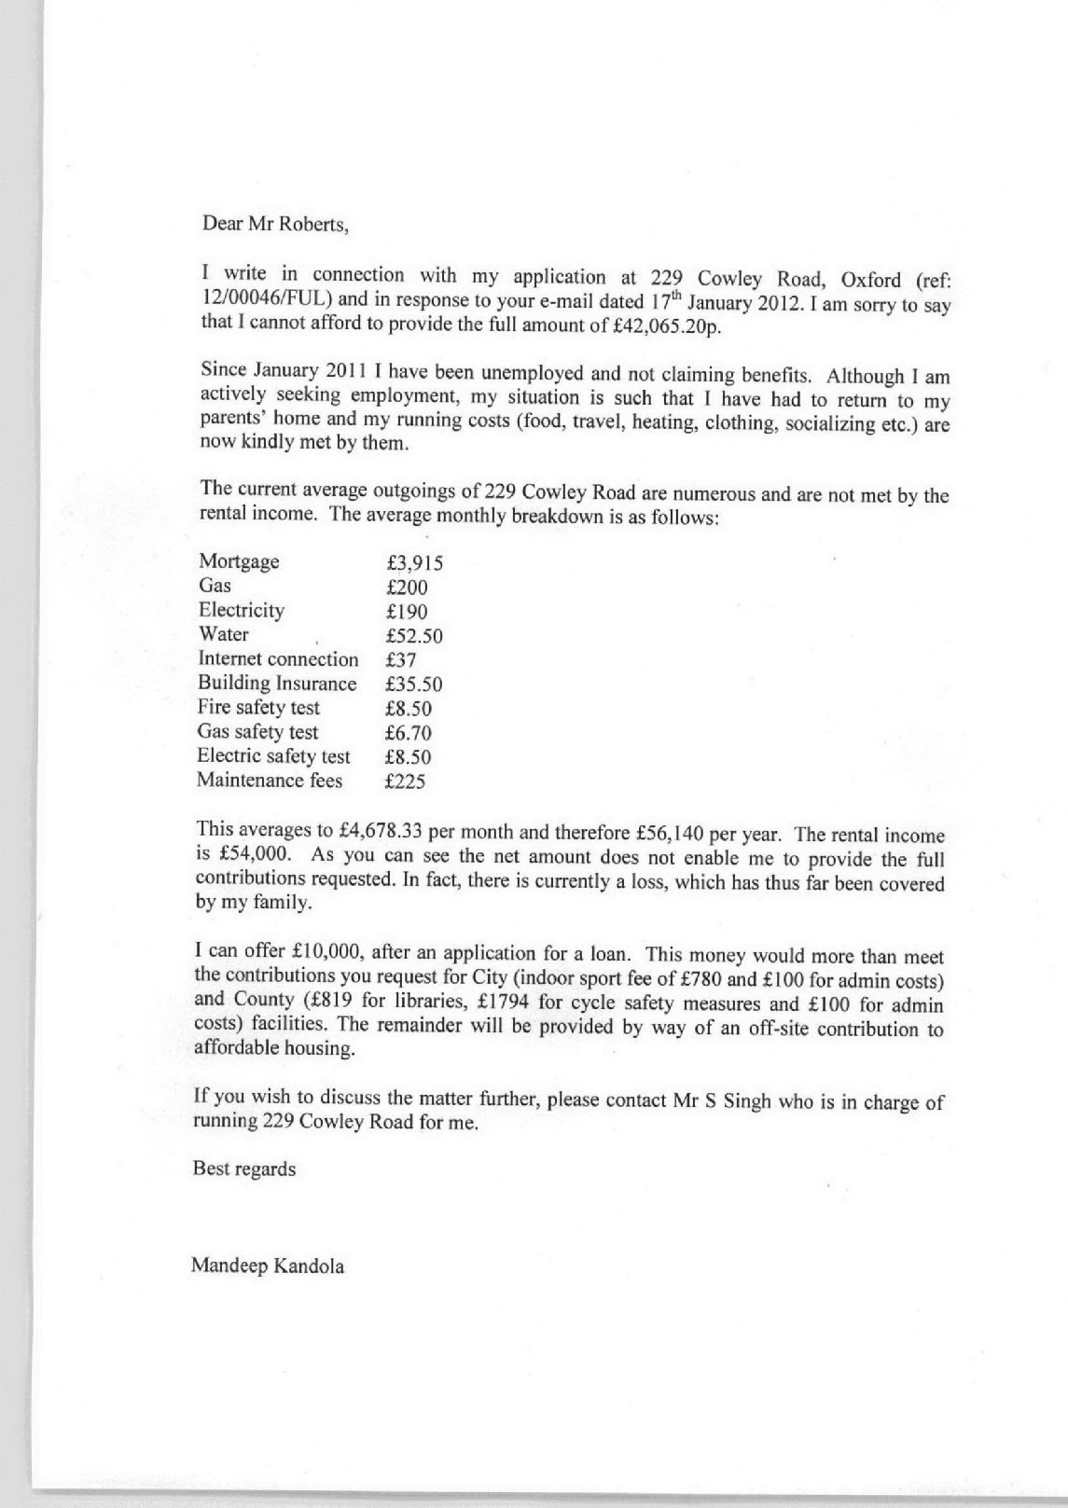

Appendix 3 – Enforcement Appeal Decision 26th July 2010



